Power Circuit

This document describes the power circuit – the electronics required to power the electronics and to charge the battery.

Inhoudsopgave
Power Circuit 1
Power Circuit 2

Power Circuit

The unit is to be powered via battery, a 18650 LiPo. This battery has an operating voltage of 3.7V To charge the battery a charging circuit with protection is used, this eases handling the battery and prevents overcharging it. Simply connect a USB cable, as long as this is connected the battery will be charged. Charging voltage is 4.2V.
The microcontroller (ESP-01) has an operating voltage of 3.3V. To overcome this difference a step-down convertor is used. By connecting this to the battery it will provide a stable 3.3V – regardless if the battery is being charged or not.
Note: at the moment the regulator cannot be turned off.
In future a swich is to be added to be able to disconnect power entirely.

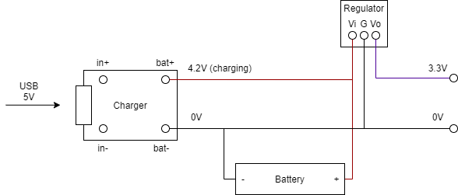
Schematic:

Final result:
